**Task 9: Package the Kubernetes deployment into a Helm chart and deploy it. Include parameters for customization (replicas, image tags).**

**Expected Output**: helm-chart.tgz, values.yaml, Helm deployment logs.

* **helm-chart.tgz**



* **values.yaml**

replicaCount: 2

image:

tag: "latest"

ingress:

enabled: true

host: nginx.local

annotations:

kubernetes.io/ingress.class: "nginx"

tls: []

service:

name: nginx-service

type: LoadBalancer

port: 80

targetPort: 80

protocol: TCP

selector:

app: nginx

serviceAccount:

create: true

name: ""

autoscaling:

enabled: false

minReplicas: 1

maxReplicas: 5

targetCPUUtilizationPercentage: 80

ingress:

enabled: true

className: "nginx"

annotations:

kubernetes.io/ingress.class: "nginx"

hosts:

- host: nginx.local

paths:

- path: /

pathType: ImplementationSpecific

tls: []

* **Helm deployment logs**

$ kubectl get all

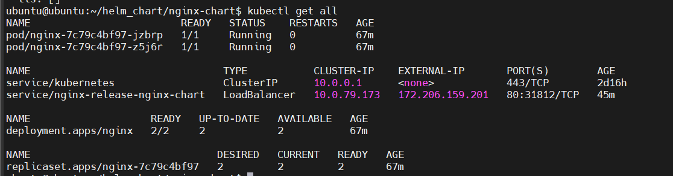

$ helm status nginx-release

NAME: nginx-release

LAST DEPLOYED: Sun Feb 16 05:35:17 2025

NAMESPACE: default

STATUS: deployed

REVISION: 1

NOTES:

1. Get the application URL by running these commands:

<http://nginx.local/>

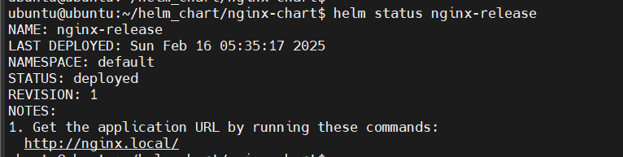

$ curl <http://nginx.local/>

